PORTABLE INCIDENT MANAGEMENT SYSTEM (PIMS) PROPOSAL

INTERSTATE 84 CORRIDOR

**Background**

The State of Connecticut Department of Transportation in cooperation with the Federal Highway administration, participated in three self-assessments covering Work Zones, Traffic Incident Management and Safety in the year 2003. As a result of the self-assessments, action items were identified in each area. In the area of “Work Zones- Construction and Operations” the need for implementation of variable message signs (VMS), highway advisory radio (HAR) and portable cameras along with other public information tools was identified as a primary action item. In addition, a need was identified under “Work Zone- Leadership and Policy” to develop measures for tracking safety and congestion.

In conjunction with the action items identified previously, the FHWA Connecticut Division office has established a strategic goal for FY 2004 in the area of Mobility and Productivity. The national performance objective is for all states to engage “in aggressively anticipating and mitigating congestion caused by highway work zones and traffic incidents.” As a result of the work zone assessment and the national performance objective, a multi-disciplinary team was established as part of the FY04 Connecticut Division’s Unit Performance Plan. The joint ConnDOT and Division office team are focusing on minimizing the occurrence of or addressing and alleviating corridor-based congestion issues, initially resulting from work zone activities and traffic incidents. The I-84 corridor was selected for review during FY04.

The task force committee consists of Bob Ramirez and Bonnie Dubose from FHWA- CT Division, Hal Decker and John Korte from Highway Operations and Terri Thompson from the Office of Construction. The task force has identified a need for an increased number of locations for variable message signs, cameras and highway advisory radio in the 84 corridor. At present, extensive construction work is occurring on I-84 Cheshire-Waterbury area within the vicinity of two major interchanges, Route 8 and I-691. Work zone delays and traffic incidents in these areas result in traffic queues extending as far back as Danbury, Torrington, Shelton and Plainville. A review of the current and future incident management systems (IMS) for this area was conducted and locations of portable variable message signs, highway advisory radio and cameras were determined.

# **Current IMS Status**

As of March 29, 2004 the status of IMS in the I-84 corridor is:

1. Variable Message Signs - Refer to Attachment A, “Existing Variable Message Sign (VMS) Locations” Map
   1. Westbound direction- No VMS currently active from Hartford to New York Line
   2. Eastbound direction- No VMS in place from New York line to Shuttle Meadow underpass in Southington (east of exit 32, Route 10)
2. Highway Advisory Radio (HAR)
   1. There is no HAR in place on I-84 from East Hartford to New York State line.

# **Planned IMS Project**

1. Variable Message Signs - Refer to Attachment B, “Variable Message Sign (VMS) Locations” Map
   1. I-84 from Pierpont Road to Hamilton Street, Project 151-273, to install and activate permanent IMS as part of first phase of project. Conduits, etc. being installed under project 151-274. However, project advertisement has been pushed further out to December 2005 with possible start in 2006.
   2. I-84 Plainville (Rt. 72-interchange area) easterly into Hartford, has permanent VMS being installed and will be active by end of 2004.
   3. I84 from Hamilton Street to Route 8 interchange, stand-alone IMS projects 151-278 & 151-286/287. This project will provide IMS at 84 & 8 interchange area. Project is in design stage and is forecasted 5 to 10 years out.
   4. No VMS from Route 8 westerly is planned at this time.
2. Highway Advisory Radio (HAR)
   1. HAR locations will be in place as part of Project 151-273, and stand-alone IMS projects 151-278 & 151-286/287. These projects will provide coverage for I-84 corridor from Plainville westerly to Route 8 interchange and completion of VMS work is forecasted 5 to 10 years out.

## **Recommended Proposal**

Interstate 84 is a major east-west corridor across Connecticut that carries a significant volume of traffic that includes not only passenger cars but also tractor-trailers and oversize/overweight loads. With the onset of construction work in the Waterbury area, work zone activities have increased congestion. There have been several significant traffic incidents in the construction area and surrounding roadways that have also impeded traffic flow. Delays effect mobility through this corridor as well as adjacent roadways such as Route 8, I-691, and Route 72. With the traffic volumes and construction activity heaviest in the southwestern portion of state along the I-95 corridor, the most viable interstate route is 84 for ALL types of traffic. This route is used heavily by oversize/overweight vehicles because of restrictions and congestion along I-95 traffic.

The unavailability of any type of incident management system along one of the three most heavily used routes in the state creates frustration on the part of the motorists, and doesn’t allow the department the ability to adequately analyze, troubleshoot and mitigate work zone and traffic incidents that occur in the 84 corridor. The opportunity to engage a portable incident management system in a short period of time with the ability to relocate and reuse if necessary, is a tremendous advantage. The need to get some form of IMS in place is critical because of the amount of construction activity that has and continues to occur in the Waterbury area, along with a number of traffic incidents resulting in significant delays. A permanent IMS is not going to be in place until at least 2006 and that will cover only area westerly to Route 8 interchange. No permanent IMS is scheduled to begin in near future for remaining western section of 84. The portable IMS will assist in mobility and congestion issues until future systems are permanently in place. In order to get the system on line by the summer of 2004, Phase I should start immediately. Work must commence by late spring 2004.

A substantial portion of the work to implement the portable IMS has been done in the exploratory and scoping stages as part of task force’s work. Implementation of the recommended proposal will provide a means to identify, quantify and reduce corridor congestion from work zone activities and traffic incidents.

It is recommended that the work be completed in two phases. Phase II would have some of the work completed in Phase I at VMS site to accommodate power and communication lines. The cameras including foundation and support would be completed in Phase II.

1. **Phase I** 
   1. Portable Variable Message Signs - Install portable variable message signs on staged platforms at five sites along I-84 and two locations on Route 8 (Refer to Attachment B) to provide motorist information on corridor incidents and construction closures. Locations are based on ability for motorists to be given advanced warning of possible delays and ability to access alternate routes if desired.

**Site 1-** I84 EB at Tunnel road in Newtown between Exits 9 & 10**∗**

**Site 2**- I84 EB at Route 172 in Southbury at Exit 14 **∗**

**Site 3**- I84 EB at Washington Street in Waterbury between Exits 22 & 23

**Site 4**- I84 WB at Prospect Street in Southington between Exits 30 & 31

**Site 5**- I84 WB at Long Swamp Road in New Britain between Exits 36 & 37

**Site 6**- Route 8 NB in Naugatuck at Exit 26

**Site 7**- Route 8 SB in Waterbury at Exit 36

**∗** Site 1 and 2 should not be deactivated after the remaining portable sites (3-7) have permanent facilities in place under projects 151-273/278/286/287. These sites will supplement the Planned IMS Projects until a future project is completed to provide IMS for western portion of 84 corridor.

* 1. Highway Advisory Radio (HAR)

**Location No. 1** at VMS Site 4 in Southington, Exit 31 area which will provide coverage from Plainville to west of I-691

**Location No. 2** at VMS Site 3 in Waterbury which will extend coverage over Route 8 and 84 interchange westerly to Middlebury.

1. **Phase II** 
   1. Portable Cameras- Install four portable cameras to assist in monitoring of traffic queues resulting from construction activities or traffic incidents. Cameras will be located

**Site 1-** I84 EB at Tunnel road in Newtown between Exits 9 & 10

**Site 2**- I84 EB at Route 172 in Southbury at Exit 14

**Site 3**- I84 EB at Washington Street in Waterbury between Exits 22 & 23

**Site 4**- I84 WB at Prospect Street in Southington between Exits 30 & 31

The above work would be accomplished via a change order to State Project No. 0025-0133, Federal Aide No. NH-84-2 (184) 39. The work would be paid as Cost Plus- Extra Work in accordance with current specification. Construction inspection and testing costs would be covered under the contract also. Eligible funding for engineering and incidentals associated with this work by Electrical Engineering and Highway Operations should be paid under project 170-1360 to reduce costs under 25-133. Project 170-1360 is the PE portion for State Project 151-273, realignment of I-84 in Waterbury. The construction project is still in design and the final design phase is projected to be some time in December 2005 with an anticipated start date in June 2006. The estimates shown on Attachment C and D for the construction portion are based on recent bid prices for similar work. All preliminary work and coordination will take place between Highway Operations, State Design- Electrical Engineering, District 1 (administrator for Project 25-133) and the Office of Construction. The task force will continue as oversight during the construction and implementation phase.

Both the FHWA and the Department are looking into alternative funding sources to reduce the financial impact on current projects.

Phase I (VMS & HAR) = $483,425.00 Refer to Attachment C

Phase II (Portable Cameras)= 264,260.00 Refer to Attachment D

Total Estimated Cost = $747,685.00

Attachment A

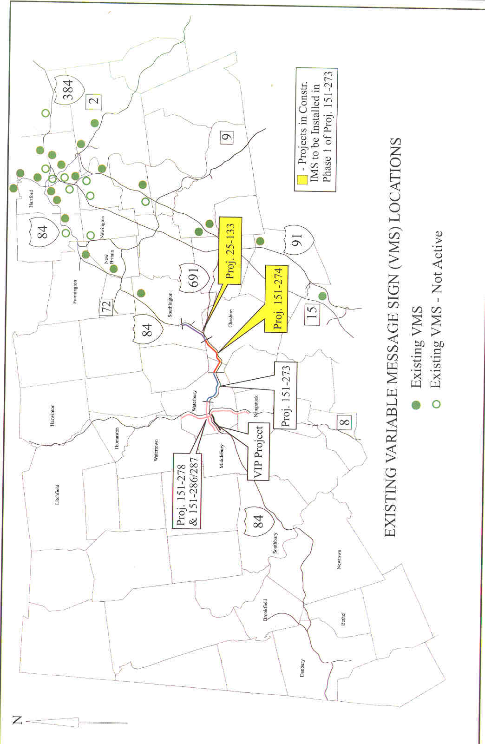

Attachment B

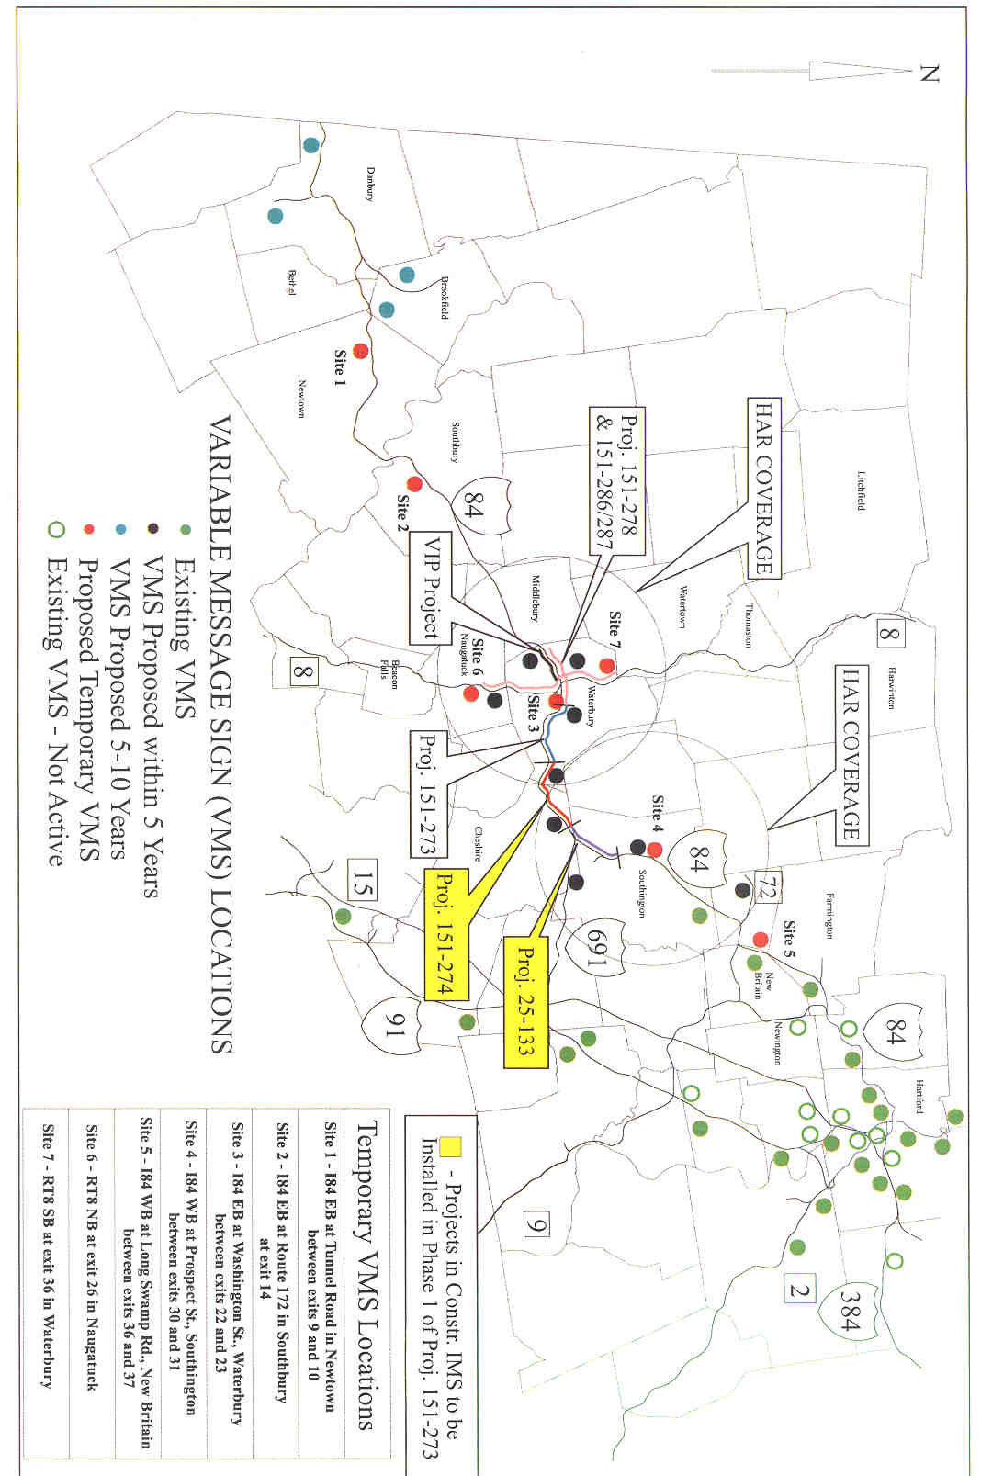

Attachment C



Attachment D

